Annexure C
(Group Member Notice)

KATHERINE CONTAMINATION CLASS ACTION

NSD 1388 / 2018 (Bartlett & Anor v Commonwealth of Australia)

1. Why is this notice important?

A class action has been commenced in the Federal Court of Australia by Mrs Kirsty Bartlett and Mr Anthony Bartlett against the Commonwealth of Australia (Commonwealth). The class action was commenced on 22 August 2018.

The class action claims compensation for damages to property as a result of contamination of groundwater, surface water, soil and biota in Katherine by per- and polyfluoroalkyl substances (PFAS) from the use of Aqueous Film Forming Foam (AFFF) by the Commonwealth at RAAF Base Tindal.

Mr and Mrs Bartlett’s lawyers are Shine Lawyers (Shine Lawyers), and they are helping them run the case. A company called IMF Bentham Ltd (IMF Bentham) is funding the case.

Important steps are taking place in this litigation, with the hearing of the claim commencing in August 2019. The Federal Court has ordered that this notice be published to alert Group Members that they must decide by 19 July 2019 whether they wish to opt out of these proceedings, and of certain amendments which have been made to the claims advanced in the class action. Information relating to both these matters is explained in more detail below.

You should read this notice carefully, as it concerns your rights. If there is anything in it that you do not understand, you should seek independent legal advice.

THE OPT OUT DATE IS 19 JULY 2019

2. What is a class action?

A class action is an action that is brought by one or a small number of people (Applicants – in this case Mr and Mrs Bartlett) on behalf of a class of people (Group Members – this may include you) against another person (Respondent – in this case the Commonwealth) in circumstances in which the Applicants and the Group Members have the same or similar claims against the Respondent.

The Applicants in a class action does not need to seek the consent of group members to commence a class action on their behalf. Anyone who falls within the group definition is automatically included. However, persons can cease to be group members by “opting out” of the class action. This is done by filling out a form. It does not matter that a group member has signed a litigation funding agreement; they can still opt out.

Group members are "bound" by the outcome in the class action, unless they have opted out of the proceeding. A binding result can happen in two ways: judgment following a trial, or a settlement at any time. If there is a judgment or a settlement of a class action, group members will not be able pursue the same claims and may not be able to pursue similar or related claims against the respondent in other legal proceedings. Group members should note that:

- in a judgment following trial, the Court will decide various common factual and legal issues in respect of the claims made by the Applicants and group members. Group members will be bound by those findings, whether or not they are favourable to them (unless they are appealed – IMF Bentham is not required to fund any appeal). Importantly, if there are other proceedings between a group member and the respondent, neither of them will be permitted to raise arguments in that proceeding which are inconsistent with a factual or legal issue decided in the trial of common issues in the class action. This means that if the issues are resolved against the Applicants, group members will be unable to pursue claims they have which are the same as the Applicants’ claims, and will not be able to pursue other claims which are dependent upon common issues which have been resolved against the Applicants in any other Court proceeding; and

- in a settlement of a class action, where the settlement provides for compensation to group members it is likely to extinguish all rights to compensation which a group member might have against the respondent which arise in any way out of the events or transactions which are the subject-matter of the class action

If you consider that you have claims against the Commonwealth which are based on your individual circumstances or otherwise additional to the claims described in the class action (for example you have suffered different kinds of loss), then it is important that you seek independent legal advice about the potential binding effects of this class action in advance of the opt out date. If you stay in this proceeding and it is determined by a judge then you may not be able to issue separate proceedings on different, but related, grounds later on.

3. What is this class action?

This class action is brought by the Applicants (Mr and Mrs Bartlett) on behalf of all persons who are Group Members (see Section 4 below).

The Applicants allege that from 1987 onwards, the Commonwealth discharged large quantities of AFFF at RAAF Base Tindal, containing PFAS chemicals which are potentially damaging to the environment and potentially causative of adverse health effects in humans. The Applicants allege that the Commonwealth’s negligent use and failure to contain AFFF has resulted in the contamination of the Tindal Creek, the Katherine River and the aquifer (groundwater) underlying the town of Katherine and its surrounds, resulting in contamination of groundwater, surface water, soil and biota in the area. The Applicants also allege that the Commonwealth failed to inform actual and potential property owners of the contamination at any time prior to 23 November 2016, notwithstanding what it knew or ought to have known of the potential properties of AFFF, and the contamination. The Applicants claim that the Commonwealth’s conduct created a nuisance, was negligent and was in breach of the Environment Protection and Biodiversity Conservation Act 1999 (Cth).

The Applicants allege that the Commonwealth’s conduct has caused adverse impacts to the value of land in the area delineated by the solid purple line on the map annexed to this notice as Attachment “A” (Relevant Area). The following post codes are wholly or partly within the Relevant Area: 0850, 0851, 0852 and 0853. The Applicants do not claim that the Commonwealth’s conduct has caused personal injuries to them nor do they seek compensation in this regard.

The Applicants previously also alleged that the Commonwealth’s conduct has caused adverse impacts to the value of businesses in the Relevant Area, but they no longer intend to make those allegations or seek compensation in this regard (and this subject is dealt with further in Section 6 below).

The Commonwealth denies that it is liable to the Applicants and Group Members, and is defending the class action.

4. Are you a Group Member?

You are a Group Member in the Katherine Contamination Class Action if, as at 23 November 2016, you were the registered owner of land located in whole or in part within the Relevant Area (that is, if you were the registered owner of a fee simple interest in a lot within the meaning of the Land Titles Act 2000 (NT)) (Landholder Group Members).

At the time the Katherine Contamination Class Action was commenced, you were also a Group Member if you operated a business situated on land located in whole or in part within the Relevant Area even if you did not own land in the Relevant Area, however the Applicants are no longer intending to maintain claims in respect of business losses, or on behalf of persons who owned businesses but who are not also Landholder Group Members (as to which see further in Section 6 below). That means that if you fall into this category, after the end of the opt out period, you are no longer eligible to receive any monetary compensation if the Applicants achieve a successful outcome in the proceeding. If you are not a Landholder Group Member, but only a person who operated a business situated on land located in whole or in part within the Relevant Area, you should seek independent legal advice. You should also read Part 6 which relates to limitation periods which apply to you.

The class action has been brought on an ‘open class’ basis which means the proceeding has been brought for the benefit of all persons who fall within the definition of a Group Member. The class includes persons who have already signed a Funding agreement with IMF Bentham (Client Group Members) and those who have not done so (Non-Client Group Members).

If you are unsure whether or not you are a Group Member, you should contact Shine Lawyers or IMF Bentham (at the details set out in Section 8 below) or seek your own independent legal advice without delay.

5A. How is the class action being funded?

Group members in a class action are not individually responsible for the legal costs associated with bringing the class action. In a class action, only the Applicants are responsible for the costs.

The Applicants and Client Group Members have entered into Funding Agreements with IMF Bentham which provide for IMF Bentham to pay the Applicants’ legal costs of the action, to indemnify the Applicants in respect of any adverse costs orders which may be made against the Applicants in the action, and to provide any security for adverse costs in the action (that is, any amount the Applicants have to pay the Commonwealth if the class action is lost). In exchange for IMF Bentham providing funding, the Applicants and Client Group Members have agreed that in the event that there is a successful outcome to the proceedings:

(1) IMF Bentham may recover amounts which are deemed “Project Costs” on page 11 of the Funding Agreement (plus GST), including legal expenses, project investigation fees, project management fees, adverse cost orders, out of pocket expenses and other fees. These may include amounts incurred prior to entry into the Funding Agreement. They may also recover amounts defined as “Common Project Costs” on page 8 of the Funding Agreement (plus GST), being costs incurred by IMF Bentham in funding separate class actions; and

(2) IMF Bentham will be paid a commission from any amount they recover from the Commonwealth. The commission which the Client Group Members have agreed to pay IMF Bentham is set out in the Funding Agreement at clause 12.1.3 (page 26) and in Schedule 5 on page 50 (being, relevantly, a part of what is set out in the table below).
Under the Funding Agreement, IMF Bentham is not obligated to fund the litigation until it is finalised. If IMF Bentham chooses to terminate the Funding Agreement it will not be responsible for any costs of the litigation after it makes its decision.

5B. Common fund order will be sought

Non-Client Group Members do not presently have any obligation to pay IMF Bentham a funding commission from any judgment or settlement in exchange for IMF Bentham funding these proceedings. However, as IMF Bentham is funding these proceedings for the benefit of Group Members, in the event that there is a judgment or settlement, the Applicants intend to seek what is known as a common fund order (CFO). The effect of a CFO would be that if there is a successful resolution to the class action (whether by settlement or judgment), all Group Members (not just those who are Client Group Members) would have to pay out of any amounts they recover:

a) a share of the total costs and disbursements incurred in running the class action for the benefit of group members, that the Court considers to be fair and reasonable, including legal expenses, project investigation expenses, project management expenses, adverse cost orders, out of pocket expenses and other fees and such amount of the costs and expenses incurred by IMF Bentham in relation to two separate class actions that the Court considers to be fair and reasonable and to have benefitted Group Members such that they ought to be shared between Group Members in each of those proceedings; and

b) a funding commission that the Court considers to be fair and reasonable (Funding Commission).

If there is a successful resolution of these proceedings, the Funding Commission that will be sought is as set out in the following table (column A + column B), which is the same funding commission as that which Client Group Members have agreed to pay in their Funding Agreements (as described above):

 | A | B
Date on which IMF Bentham receives the settlement or judgment sum | Multiple of Court approved costs and disbursements | PLUS a percentage of the gross settlement or judgment sum
14 June 2019 to 14 December 2019 | 2x | 15%
15 December 2019 to 14 June 2020 | 2.5x | 15%
15 June 2020 to 14 June 2021 | 3x | 15%
After 15 June 2021 | 3.5x | 15%

If there is an appeal of a judgment in the court proceedings, then component B of the funding fee will be sought to be increased by an additional 5% (i.e., it will be 20% of the gross judgment sum upheld or varied by the appeal court).

Important Note: No Group Member will be liable to pay any amount of money to IMF Bentham or Shine Lawyers unless there is a successful outcome in the proceeding. If a successful outcome is reached (subject to any order the Court might make), the amounts payable by Group Members will be deducted from the settlement or judgment sum before the balance is distributed to Group Members, and you will never need to pay any money out-of-pocket to IMF Bentham or to Shine Lawyers. The amounts paid in the event of a successful outcome will not exceed the settlement or judgment sum.

6. Business claims

When it was commenced, this class action also alleged that the Commonwealth’s conduct has caused adverse impacts to the value and/or profitability of businesses in the Relevant Area. The Applicants (who themselves are not business owners) have, however, applied to the Court to amend the class action to remove those claims. The Court has ordered that this amendment will only take effect after the Opt Out date (of 19 July 2019). On that date, claims on behalf of business owners who are not also Landholder Group Members will no longer be part of this class action, and any such group member who considers they may have a claim in relation to their business will need to take steps to prosecute their claim themselves outside of this class action.

At the moment, if you are group member who considers you have a claim in relation to a business even if you are not also a Landholder Group Member, you may be presently protected from the expiry of limitation periods applicable to your claim by federal legislation which suspends those limitation periods upon the commencement of a class action which relates to your claim. When the amendment removing business owner claims takes effect, time will start running again because claims on your behalf will not be part of the class action anymore.

Therefore, if you are group member who considers you have a claim in relation to a business you should consider and take independent legal advice about your position, especially if you are not also a Landholder Group Member. You may need to take steps quickly in order to protect any rights you may have arising from any claim you have in relation to a business. If you have signed a funding agreement with IMF Bentham, you should also obtain independent legal advice about the impact of the decision to remove claims for business losses from the class action.

7. What do you need to do?

If you are a Group Member in this proceeding, you have two options:

Option | Deadline | More Information
1. Stay in the class action (do nothing) | 19 July 2019 | Section 7(a) below
2. Opt out of the class action | 19 July 2019 | Section 7(b) below

(a) OPTION 1: If you want to be part of this class action

You do not need to do anything to stay as a Group Member in this class action.

If you stay as a Group Member you will be bound by the outcome of the class action, as described in Section 2 above. If it is successful, you will be eligible to benefit from any favourable outcome that is reached in the class action and may need to provide evidence to substantiate your claim as a group member. You will also be bound by any orders that the Court makes in relation to the payment of costs, including legal fees and the funding commission payable to IMF Bentham. These will prevail over any litigation funding agreement you have signed to the extent of any inconsistency.

As noted above, the class action will only proceed in respect of claims in relation to adverse impacts on property. If you are a business owner and not also a property owner, if you do nothing the consequence will be that the class action proceeds in relation to your claims as a property owner, but not in relation to any claims you may have in respect of business losses. If you are concerned about this you should seek independent legal advice without delay.

(b) OPTION 2: If you do not want to be part of this class action

If you do not wish to be a Group Member in this class action you should opt out. If you opt out you will not be bound by the outcome of the class action, as described in Section 2 above. If you opt out, you may:

- take no further action against the Commonwealth; or

- commence your own proceedings against the Commonwealth. If you want any claim you have against the Commonwealth to be pursued you will need to take steps to bring it, and fund it, yourself, which you are free to do provided that you issue Court proceedings within the time limit applicable to your claim; or

- make a financial claim against the Commonwealth in writing (for example, by using the claim form available at:
http://www.defence.gov.au/Environment/PFAS/FinancialClaims.asp).

You should seek independent legal advice about your claim and the applicable time limit prior to opting out of this class action. Additionally, if you are a Client Group Member you should seek specific legal advice if you are opting out about the effect of the litigation funding agreement you have already signed with IMF Bentham, including where you intend to pursue a claim against the Commonwealth, as it may bear upon your rights if you opt out (including your rights to any moneys paid to you by the Commonwealth if you opt out and commence your own proceedings against the Commonwealth or make a financial claim against the Commonwealth).

If you do not wish to remain a Group Member you must opt out of this class action by completing an "Opt Out Notice" in the form shown at Attachment “B” to this notice, and returning it to the Registrar of the Federal Court of Australia at the address on the form. IMPORTANT: the Notice must reach the Registrar by no later than 19 July 2019, otherwise it will not be effective and you will not be able to opt out of the proceeding.

8. Where can you obtain copies of relevant documents and advice?

Copies of relevant documents, including the pleadings and relevant notices, may be obtained by:

- downloading them from https://www.shine.com.au/service/class-actions/pfas-contamination-class-actions/katherine-contamination; or

- Inspecting them between 9am and 5pm at one of the offices of Shine Lawyers by prior appointment to be made by emailing KatherineContamination@shine.com.au.

If there is anything of which you are unsure, you should contact Shine Lawyers (KatherineContamination@shine.com.au; 1800 066 105) or IMF Bentham (403619@imf.com.au;1800 016 464) or seek your own independent legal advice.

“Attachment A to Notice”
Relevant Area

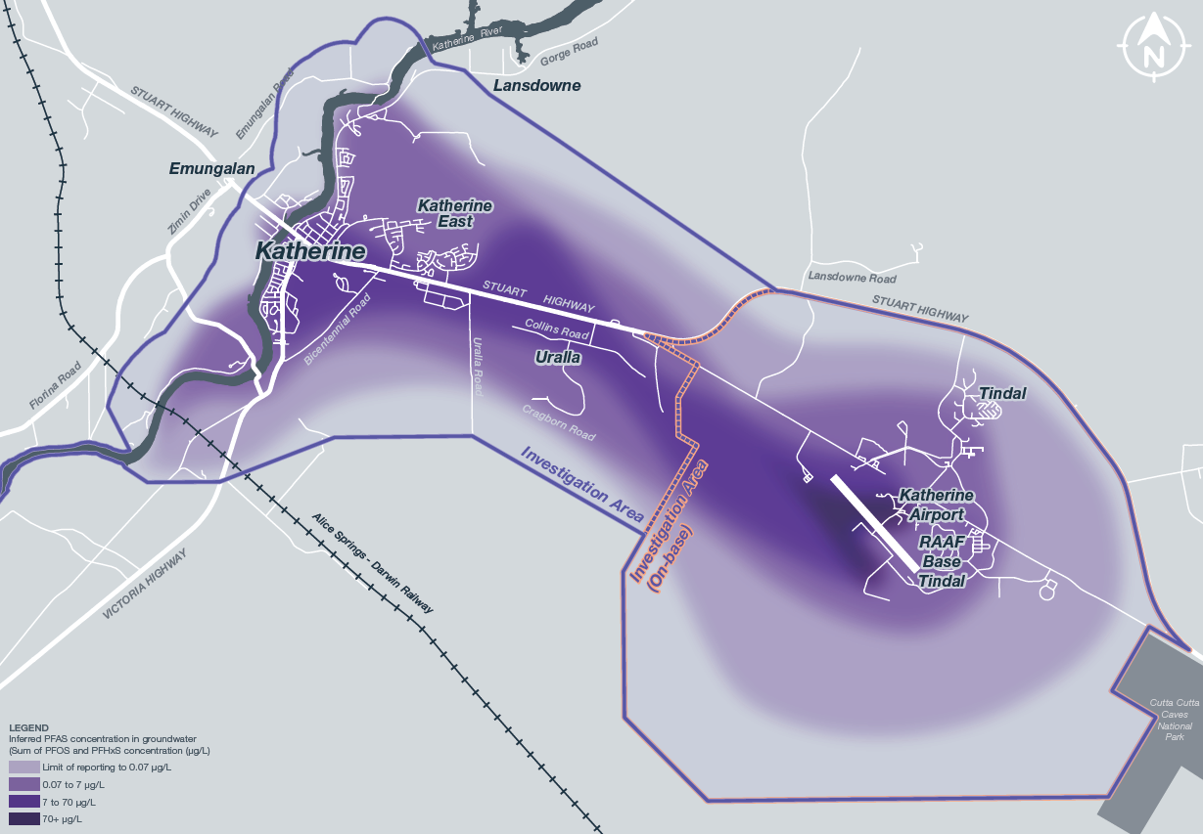

“Attachment B to Notice”

Form 21
Rule 9.34
Opt out notice
No. 1388 of 2018
Federal Court of Australia
District Registry: New South Wales
Division: General

Kirsty Jane Bartlett & Anor
Applicants

The Commonwealth of Australia
Respondent

To: The Registrar
Federal Court of Australia
New South Wales District Registry Locked Bag A6000
Sydney South NSW 1235

……………………………,
[Name of group member]

a group member in this representative proceeding on the basis that they own (insert land) ……………………………………, gives notice under section 33J of the Federal Court of Australia Act 1976, that

……………………… is opting out of the representative proceeding.
[Name of group member]

Date: ………………………
[DD Month YYYY]

……………………………………_________________________________________________

Signed by  Capacity: |  |  | …………………….  [Name]  …………………….  [e.g. Group Member/ Lawyer for the group member]
Filed on behalf of (name & role of party)
Prepared by (name of person/lawyer)
Law firm (if applicable)
Tel |  |  |  |  |  |  | Fax
Email
Address for service
(include state and postcode)

